The Title Should Be Written in Title Case Except for Words Such as, and the
(It can be up to 2 lines in length)
Author¹, Author¹, Author², & Author³
Affiliation¹, Affiliation², Affiliation³
Author¹@xxxxx.com
- Abstract (Arial 10, numbered)
Titles of each subsection should be determined by the authors. The authors may also add subsections as appropriate.
Body text should be justified, Times New Roman 10 point. Numbers one through nine should be written in words while 10 and above are written in numerals. Body text should be justified, Times New Roman 10 point. Numbers one through nine should be written in words while 10 and above are written in numerals. Body text should be justified, Times New Roman 10 point. Numbers one through nine should be written in words while 10 and above are written in numerals. Body text should be justified, Times New Roman 10 point. Numbers one through nine should be written in words while 10 and above are written in numerals.
Body text should be justified, Times New Roman 10 point. Numbers one through nine should be written in words while 10 and above are written in numerals. Body text should be justified, Times New Roman 10 point. Numbers one through nine should be written in words while 10 and above are written in numerals.
- Results & Discussion (Arial 10, numbered)
Body text should be justified, Times New Roman 10 point. Numbers one through nine should be written in words while 10 and above are written in numerals. Body text should be justified, Times New Roman 10 point. Numbers one through nine should be written in words while 10 and above are written in numerals. Body text should be justified, Times New Roman 10 point.
Body text should be justified, Times New Roman 10 point. Numbers one through nine should be written in words while 10 and above are written in numerals. Body text should be justified, Times New Roman 10 point.
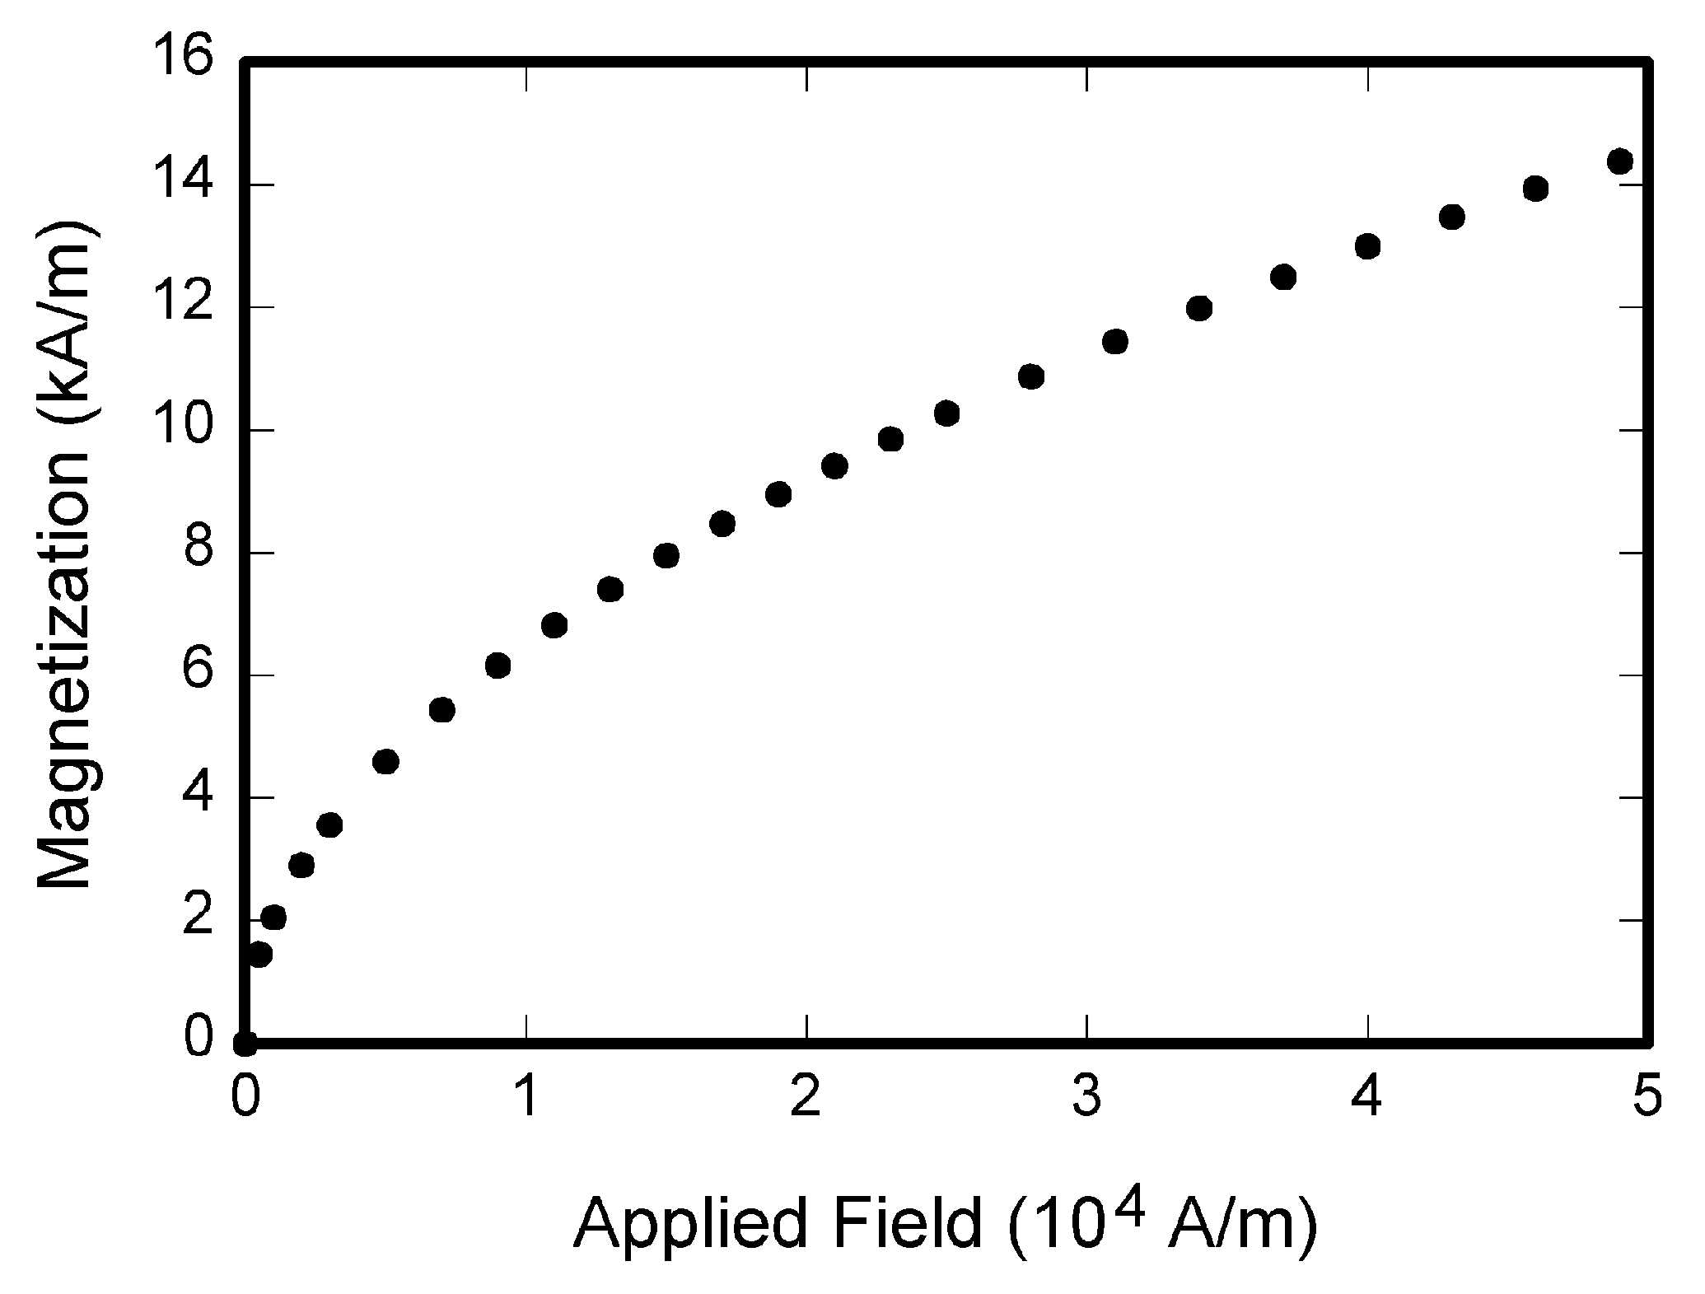
Figure 1. Magnetization as a function of applied field. Figures must be referenced in the text. Captions should be Times New Roman 8 point font.
Table 1: Table Format
 | Details
Font | Times New Roman 10 point font.
Others | Tables must be referenced in the text. Tables must not be images. Tables should be created with the table function of Microsoft Word.

- Conclusion (Arial 10, numbered)
Body text should be justified, Times New Roman 10 point. Numbers one through nine should be written in words while 10 and above are written in numerals. Body text should be justified, Times New Roman 10 point. Numbers one through nine should be written in words while 10 and above are written in numerals. Body text should be justified, Times New Roman 10 point.
Body text should be justified, Times New Roman 10 point. Numbers one through nine should be written in words while 10 and above are written in numerals. Body text should be justified, Times New Roman 10 point. Numbers one through nine should be written in words while 10 and above are written in numerals. Body text should be justified, Times New Roman 10 point.
- References (Arial 10, numbered)
References should use any widely accepted referencing style from the field of the authors. If the author(s) has/have no preferences, we recommend APA style. Text should be Times New Roman 20 point.
References should use any widely accepted referencing style from the field of the authors. If the author(s) has/have no preferences, we recommend APA style. Text should be Times New Roman 20 point.

